In order to argue for my assignment for clearly, I underline what you say and insert my feed back between them.

Just ignore what I say above, let us look at our work.

We will mark functionality, performance, ease of use,
code (HTML, JQuery, Javascript, ...) quality. We will not address
security for this application. Do not attempt to encrypt traffic,
etc. for this application. There is no HTTPS involved.
We will only mark usability for e7, e8 and e9, we will mark
website design and effective use of bootstrap for e9.
A trivially minimal interface is acceptable for e6, e7 and e8.
That is, for e1-e8, you do not need a Site ID,
no menues, no additional web pages etc. These are just development
applications, used to explore technologies and application design.
e9 is the only 'production website'.
Exercise 6 (e6): [0/5] Multiple browsers playing tic-tac-toe together.
20 marks for a simple, working Exercise 6
[NO] Communication between all clients on a single world. There may be glitches, but allow them.
World created in one is not visible in the other.
We get 0 marks for exercise 6. Pictures are too large to contain but I think it is necessary here.
As requirement, I first node e4server.js.
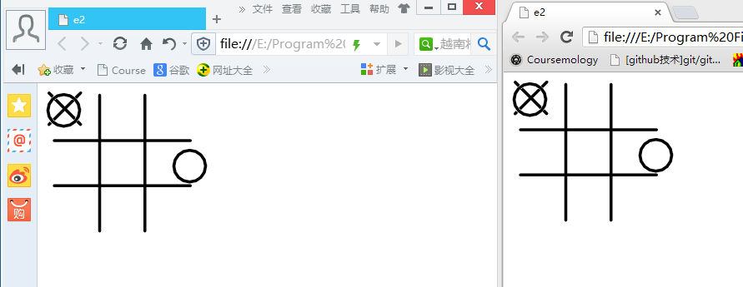
Then, I open two windows with two different browser, and make some changes. Why the people who mark our assignment just give us a zero for exercise 6?

I also have code to prove what I have done.

On the client, I have
socket.onmessage = function(event) {
console.log(event.data);
var updateposition = JSON.parse(event.data);
//$("#world img").each(function(e){
// console.log(updateposition);

// console.log($(this).attr('id'));
//if (updateposition[$(this).attr('id')] !== undefined) {
// $(this).css("top",updateposition[$(this).attr('id')].top);
// $(this).css("left",updateposition[$(this).attr('id')].left);
//}
// });
$.each(updateposition,function(key,value) {
$("#"+key).css("top",value.top);
$("#"+key).css("left",value.left);
});

}
That means once the server give me something, I would update the position.
Then, let us look at how it works at the server:
wss.broadcast = function(data) {
for(var i in this.clients)
this.clients[i].send(data);
};

wss.on('connection', function(ws) {
wss.broadcast(JSON.stringify(world));
ws.on('message', function(message) {
console.log('received: %s', message);
var messageObject = JSON.parse(message);
world=messageObject;
wss.broadcast(JSON.stringify(world));
});
});

Once I receive any message from the client, I would change all the clients’ worlds.

Let’s move to the exercise 7. I would try to get back my marks one by one.

First of all, the description of exercise 7 is very ambiguous.
It asks us to fix the problem in exercise 6, but it did not indicate what exact problems we need to fix. I have fixed all the problems in exercise 8 and 9. As time limits, I do not fix all the problems in exercise 7 and I really think it does not matter because I have solved the rest of them in exercise 8 and 9. If you insisted that we need a perfect exercise 7, that makes sense, but I still think we should get the marks for some options because they are implemented in exercise 8 and 9.

Exercise 7 (e7): [1/5] Fix glitches in e6.
30 marks for a simple, working Exercise 7
[NO] Handles browser resize. If browser is resized, the application should do something reasonable and still function.
For browser resize problem, I fix this problem very well in exercise 8 and 9. In this exercise, as there is not too much limitation and the tic-tac-toe is placed with no restriction, I do not think we need to solve this problem here. Even though, I think I really do not have any size problem here!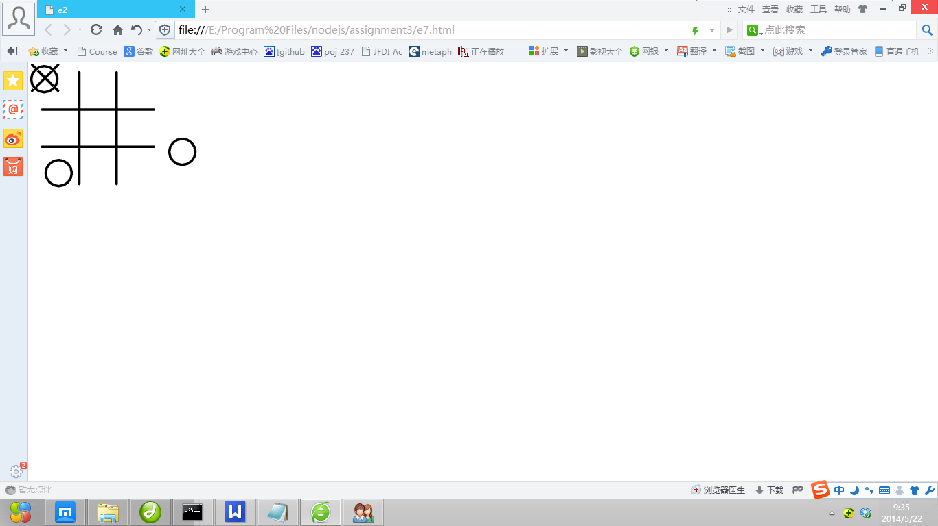
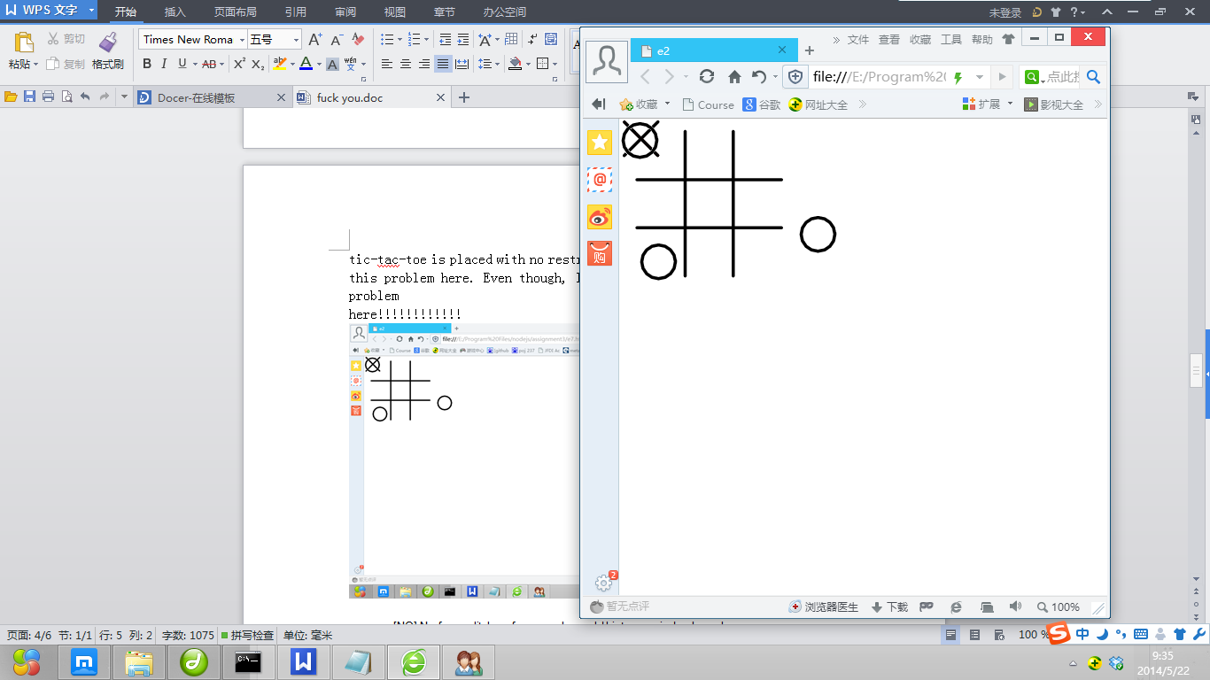
I really do not see any size problem here.

[NO] No funny clitches, for example, world history rewinds when players move.
Exercise me, is there a typo? What is clitches? Do you refer to glitch?
If you find there is any strange glitches, could you please write down what it is?

[YES] Pieces should not jump, but move smoothly. This happens when all move events are sent, or when only end positions are sent and the UI animates a move between positions.
[NO] All clients sharing the same world see the same thing eventually.
I have shown evidence in exercise 6. 7 is an updated vision for it. If you need more evidences, let me know and I would show you what you want.
[NO] Handles conflict on different moved objects
Approach: Only send changed objects position.
I admit I have not thought of this before, but I think my program do not have this problem at all because I really just send changed objects position.
In e7.html, I have
function logDrag(event, ui){
//$.each(world,function(index,value){
//console.log(JSON.stringify(ui.position) + " " + event.target.id);
//});

//console.log(JSON.stringify(world));
socket.send(JSON.stringify({"img_id": event.target.id,
"position": ui.position}));
}

And in the server, it received:
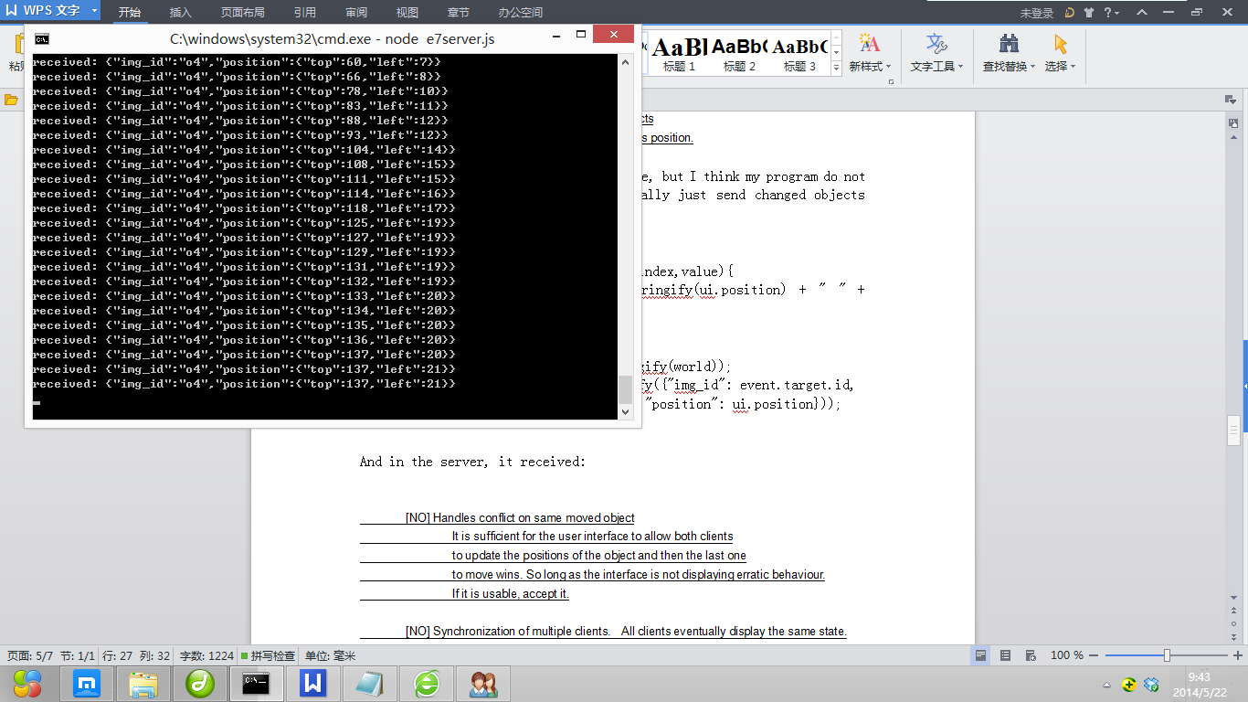

[NO] Handles conflict on same moved object
It is sufficient for the user interface to allow both clients
to update the positions of the object and then the last one
to move wins. So long as the interface is not displaying erratic behaviour.
If it is usable, accept it.
As I have said before, I do not think we are supposed to solve all the problems in exercise 6 because you do not require that. Ok, I admit I do not deal with this on purpose. But I think my program has behaved as your requirement here.

I make more improvements in exercise 8. I let all the imagines have a new property: lock.

function lockDrag(event, ui) {
if (world_id == null)
return;
moving = event.target.id;
socket.send(JSON.stringify({
"type": "lock",
"world_id": world_id,
"img_id": event.target.id
}));
}
function unlockDrag(event, ui) {
if (world_id == null)
return;
socket.send(JSON.stringify({
"type": "unlock",
"world_id": world_id,
"img_id": event.target.id
}));
}

I lock the imagines when there is someone drug it and unlock it when someone stops drugging it.

If you just want to ignore our efforts in such a try, fine. But why you do not just give us a F for this module?

[NO] Synchronization of multiple clients. All clients eventually display the same state.

Obveriously I have done. Same as exercise 6. Ok ,fine, I would show you evidence once more here for html 7.

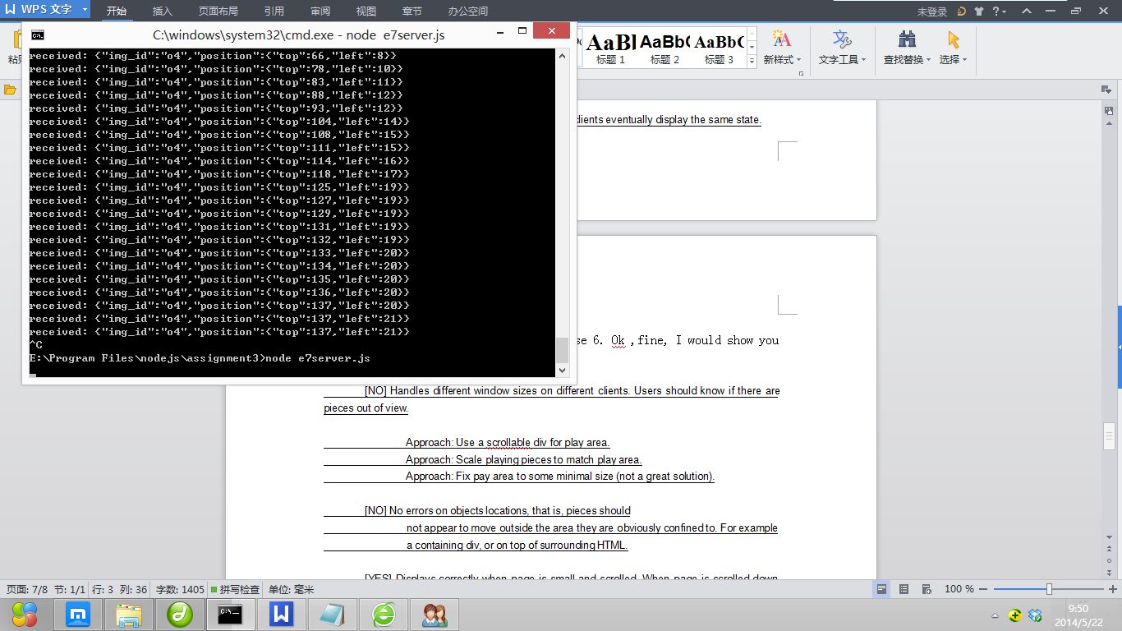
Run the server.

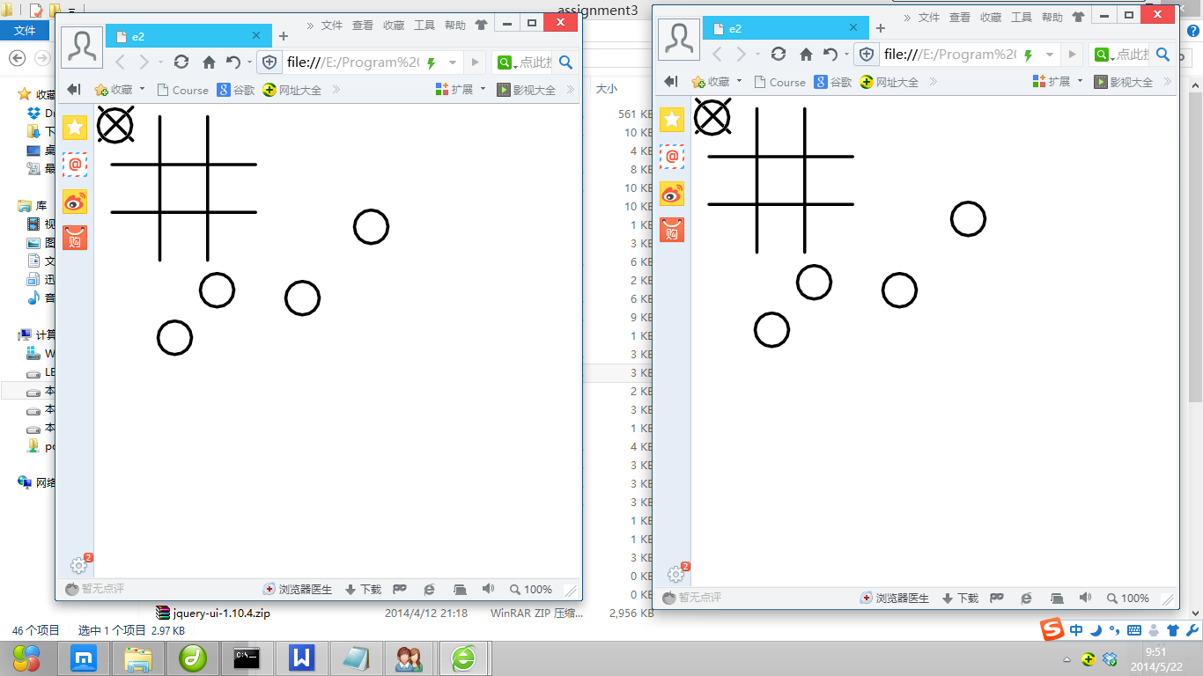
Is this enough to show I deserve a Yes for this option?
[NO] Handles different window sizes on different clients. Users should know if there are pieces out of view.
Approach: Use a scrollable div for play area.
Approach: Scale playing pieces to match play area.
Approach: Fix pay area to some minimal size (not a great solution).
I am too tired to fight for my assignment one by one. I do not get this very clearly.

[NO] No errors on objects locations, that is, pieces should
not appear to move outside the area they are obviously confined to. For example
a containing div, or on top of surrounding HTML.
As I have said before, exercise 6 and 7 do not look like some formal projects. Therefore, I do not think it proper to give a restriction to where we should put the elements in.

I restrict the position of all the elements in exercise 8 and 9 because they look much more formal and the user can find out the they should not place all the elements everywhere.

socket.onmessage = function(event) {
var data = JSON.parse(event.data);
if (data.type == "update_position") {
var cx=data.position.x;
if (cx<20) cx=20;
if (cx>430) cx=430;
var cy=data.position.y;
if (cy<20) cy=20;
if (cy>430) cy=430;
$("#"+data.img_id).css("top", cx);
$("#"+data.img_id).css("left", cy);
} else if (data.type == "create_world") {

Code is something above. Same as what I have seem before, it is you right to respect such an effort or not. But I really think we should get a yes here.

[YES] Displays correctly when page is small and scrolled. When page is scrolled down, the objects should
scroll down with the play area.
Approach: Fixed by making pieces location relative to play area.
Approach: Fixed by preventing page scrolling (not a great solution).
[NO] Issue when user resizes window. The UI should respond to window resize so that the
UI still makes sense for the adjusted play area size.
I also do not find any problems here.

I am amazing I get full marks for exercise 8. I wonder whether I have submitted the wrong code for exercise 6,7?
Exercise 8 (e8): [5/5] Multiple worlds.
20 marks for a simple, working Exercise 8
[YES] Creating new world works.
[YES] Playing new world works.
[YES] Switching worlds works.
[YES] World list properly updated on all clients. User should not have to refresh browser to see new world list.
[YES] Multiple clients on multiple worlds works.
[YES] Current world name is displayed.
works well but does not update on firefox client.
I am really sorry that we may use server name and html name wrongly. In our submission.

For exercise 9:

The server is e8server.js

The client is combine.html

The mobile feature which we use is when you shake the handphone, the world would be reset.

I cannot remember where we find such a requirement that we are supposed to use combine.html...

So really please help us remark this part.

Thank you very much.
Exercise 9 (e9): [1/5] Mobile, responsive design and mobile features.
30 marks for a simple, working Exercise 9
...
[NO] Code: Should be simple, clear, obvious, concise, make good use of Javascript and libraries.
[NO] Mobile user interface is ok
[NO] Mobile user interface is good
[NO] Mobile user interface is great
Mobile website e9.html not implemented
cannot find sharedThingsServer.js
marks give for working e8 on mobile

